**IS362 - Cohen**

**Homework Assignment #1 – Python Basics**

Connections to Course Objectives & Learning Goals:

**Course Objectives:**

* To hone data mining execution using the Python programming language

**Learning Goals:**

* Analytical and Technological skills
* Oral and written communication skills

The objective of this assignment is to practice coding fundamentals in Python. If you need a refresher, coding basics can be found below. Refresh your skills through Numpy & Pandas basics:

* <https://python.swaroopch.com/data_structures.html>
* https://www.learnpython.org/en/Hello%2C_World%21

The homework must be screenshots of your code from Jupyter Notebook pasted into **this** MS-WORD and include the Jupyter notebook as well as part of your submission. As an example, just sending the Word document without the Jupyter notebook will receive 50% credit.

**Grading Rubric**

25 points is the best possible grade. Each question represents 2.5 points, out of 25 possible points.

* **If there is no Jupyter notebook, or if it is not an .ipynb file there is a -50% point deduction on the entire assignment.**
* **If the homework is not submitted as an attachment to the email e.g. sent as a link via email or sent as a PDF, there is a -50% point deduction on the entire assignment.**

1. Let’s do an exercise in combining variables, given an input.
   1. Given input

one = 1

two = 2

three = 3

four = 4

can = can

do = do

python = python

more = more

* 1. Expected output:

1 2 3 4 can do python more

1. Based upon these numbers, please take a picture using the “Snip” function to show the code and output provide the given Input:
   1. Given Input

number1 = 15

number2 = 30

* 1. Expected output

The result is 450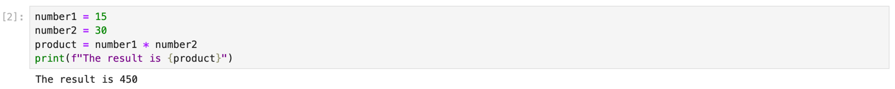

1. Write a function to return True if the first and last number of a given list is same. If numbers are different then return False.
   1. Given input:

numbers_x = [10, 20, 30, 40, 10]

numbers_y = [75, 65, 35, 75, 30]

* 1. Expected output:

Given list: [10, 20, 30, 40, 10]

result is True

numbers_y = [75, 65, 35, 75, 30]

result is False

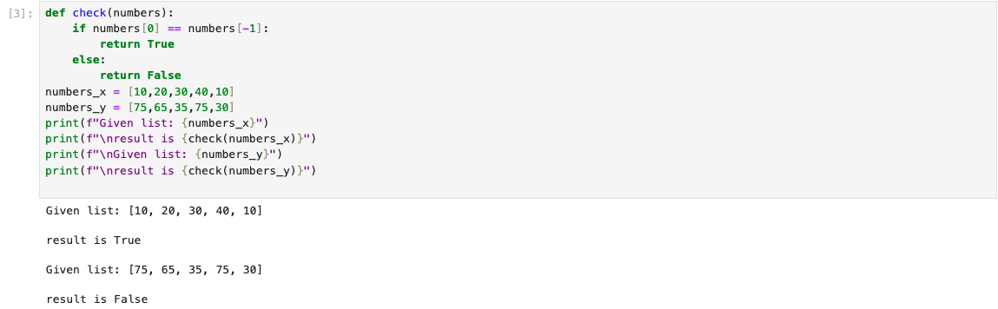

1. Iterate the given list (from #3) of numbers and print only those numbers which are divisible by 5
   1. Expected Output:

Given list is [10, 20, 33, 46, 55]

Divisible by 5

10

20

1. Write a program to find how many times substring “Anjali” appears in the given string.
   1. Given input:

str_x = "Anjali is good developer. Anjali is a writer"

* 1. Expected output:

1. Print the following pattern:
   1. Expected output:

1

2 2

3 3 3

4 4 4 4

1. Print a multiplication table from 1 to 100:
   1. Expected output:

1 2 3 4 5 6 7 8 9 10

2 4 6 8 10 12 14 16 18 20

3 6 9 12 15 18 21 24 27 30

4 8 12 16 20 24 28 32 36 40

5 10 15 20 25 30 35 40 45 50

6 12 18 24 30 36 42 48 54 60

7 14 21 28 35 42 49 56 63 70

8 16 24 32 40 48 56 64 72 80

9 18 27 36 45 54 63 72 81 90

1. Let’s now use Numpy to convert a list to an array. First, convert the list of weights from a list to a Numpy array. Then, convert all of the weights from kilograms to pounds. Use the formula Celsius (°C) = Kelvin - 273.15 to convert Kelvin to Celsius. Lastly, print the resulting array of temperatures in Celsius.
   1. Given input:

1. Let’s build a Dataframe in Pandas.
   1. Use a dictionary to create four fields:
      1. Student (use Tommy, Fred, Gail, [your first name], Randy, and Ariel)
      2. Hair Color (use Brown, Grey, Blonde, [your hair color] , Black and Brown)
      3. Eye Color (use Hazel, Green, Blue, [your eye color], Hazel and Blue)
      4. Weight in kilograms (60, 80, 76, 60, 88, 85)
   2. Index the dataframe
   3. Print out the entire dataframe
   4. # Print out hair color column as Pandas Series
   5. # Print out eye color column as Pandas DataFrame
   6. # Print out DataFrame with student and weight columns
   7. # Print out the second through fourth observations
2. ***We will count #9 as double points.***

